Scrappy 9 Degree Mug Rug Designed by Anne Marcellis
SamQuiltDesigns.com
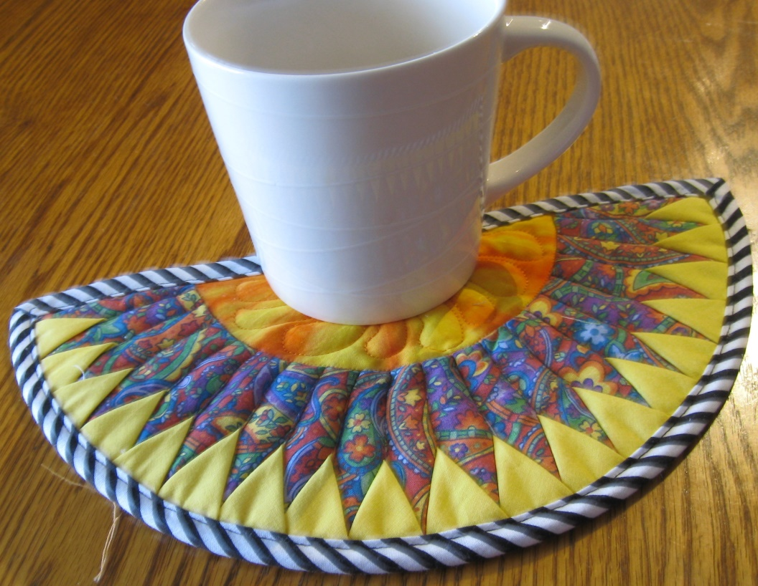

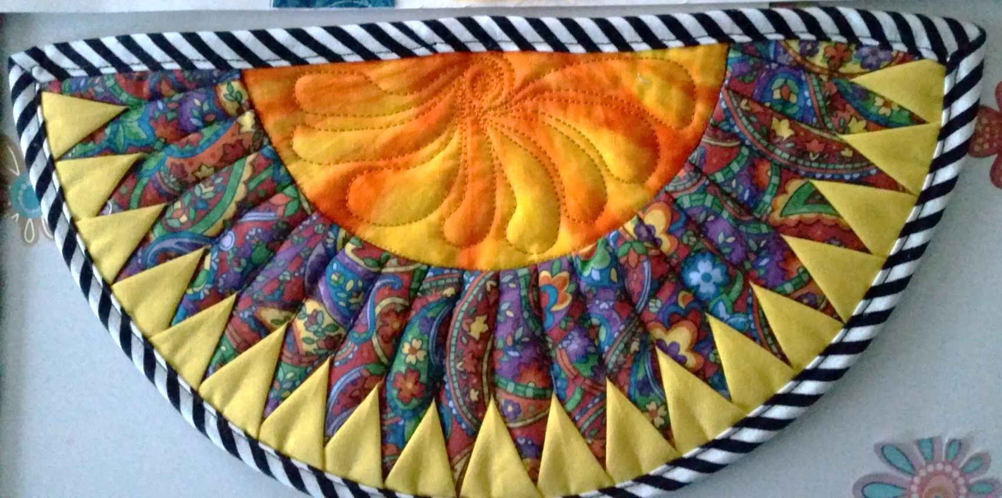

Lay the 9 degree ruler on the 6 ¼ line mark.
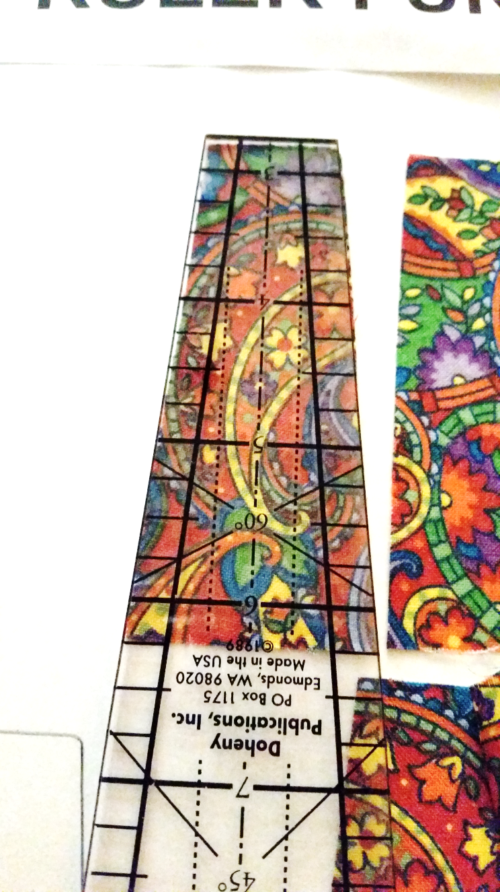
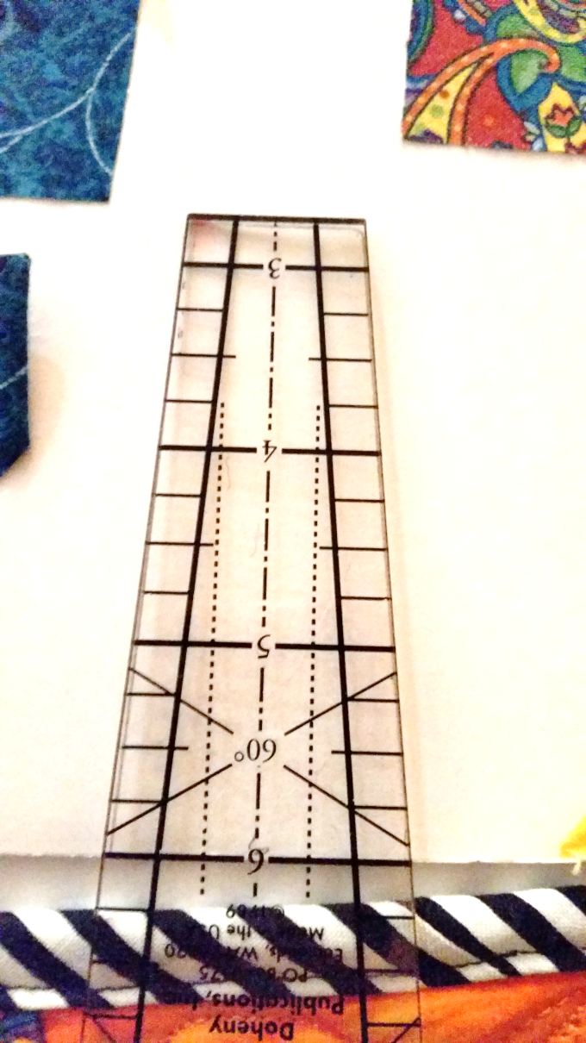

Cut 20 wedges

Cut (19) 1 ¾” squares. Press each square on the diagonal.
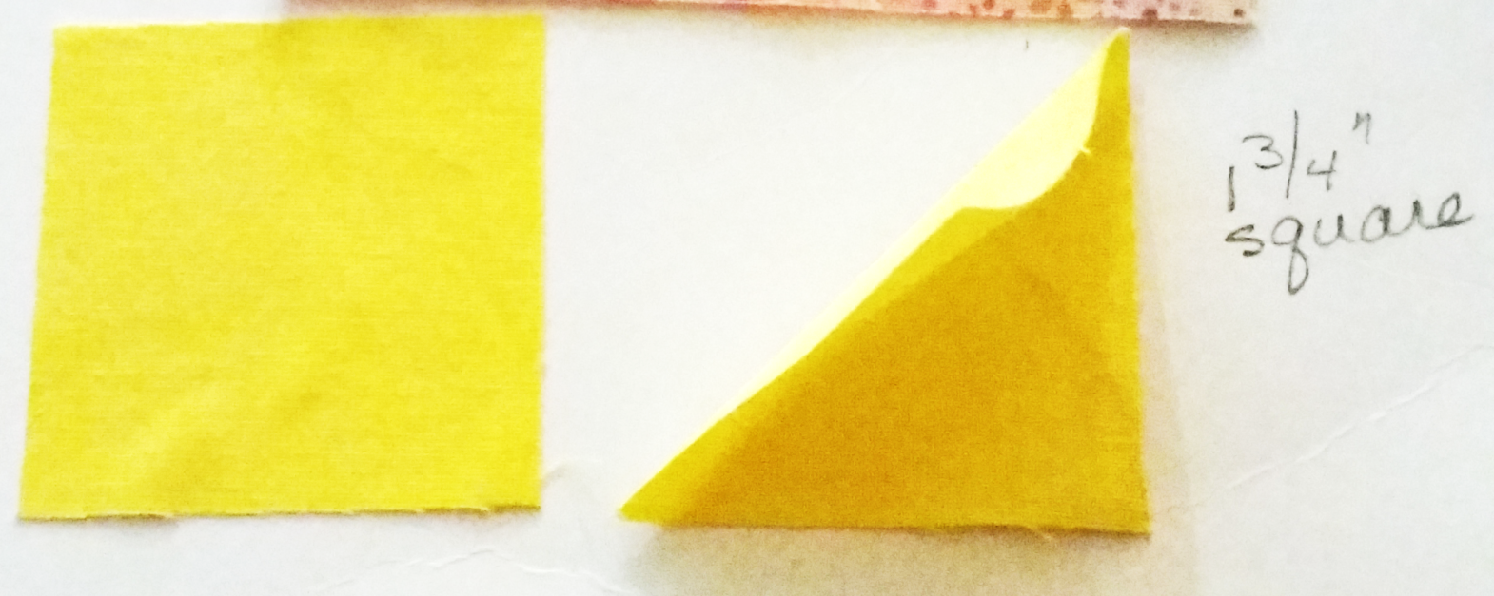

Sew triangle as shown here. Sew all wedges and triangles together.
Sandwich with batting and backing. Stitch in the ditch of the seams. Sew bias binding and enjoy a cup of coffee!

